Email Scraper App Overview

Introduction
The Email Scraper application is intended to be a forebear, augur or loss-leader for the Subscription Scraper application. See Appendix A.
We want to deliver a free – with discretionary payment – Service to Customers. We intend to prove the value of our Services. We are focusing on Emails because:
- Emails do not have direct Financial sensitivity. We are addressing Email analysis to establish trust.
- We want to establish – and assure - that we are not a Data Fishing organisation.
- Our value driven initiatives are:
  - Make Email Inbox a nicer place for Customers.
  - Improve tidiness to aid peacefulness.
  - If/where possible: reduce storage costs.

Design Principles
- The Application UI will run in a Browser Window. This will prompt for:
  - Email Address
  - Email Password
- It must be clear to the Customer that we will not store this password. It will be used ‘in memory’ for the purpose of accessing their Emails.
- If possible: we can offer a prompt to Analyse downloaded Email data, rather than going into Email itself.
- If Emails are stored on Customer device, this Service can run offline. In any case: it will run in localhost only.
  - Only Payment requires Internet access but this is, in any case, optional.
- The only Data items we will store from Customer are:
  - Email address. In order to download the .exe file that runs this application, the Customer will have provided their Email address. We already have this information.
  - Name of Application, in this case “Email Scraper”.
  - Payment amount. When Customer downloads the .exe this value will be initialised to Zero. If/when they make a Payment, this value will be updated.
  - Note that the only information we are taking – from – this Application is the Payment amount. We will get this via their Paypal Payment. This Application does not gather ANY information from Customer.

What the Application Will Do
Primary Analysis on Customer Inbox. Other boxes could be selected.
- Top level option to provide Analysis by Period. Drop down: day, week, month…
- Search box for Sender (consider content…).
- Consider a grouping option by Organisation.
- Sort options: Count, Size, Nuisance, Date (Last Received), Name, Organisation. Ascending and Descending.
- Top level actions:
  - Unsubscribe
Automate unsubscribe to sender. This means ‘delving’ into their Emails, find the unsubscribe button and action.
  - Create Folder
When selected, this action will provide a default folder name based on sender name. It will provide options to: auto file all current Emails, a rule for future forwarding. It will action i.e. file and/or create rule.
  - Manage History
When selected, this action will provide prompts to: retain only last n items, automate this action going forwards e.g. save only last 3 emails, retain only for x period e.g. 1 week, one month. Check box options to delete, or archive. Note that selecting Archive will initial the Archive functionality – it’s just another route in. It will create automation to carry out these actions going forwards.
  - Delete all
Does what it says. Include option to create ‘block’ rule to be implemented from now forwards.
  - Archive (Emails/Attachments)
Specifically intended for large sized Emails/Attachments. Provide functionality to Zip/Move to Cloud/Move to Cool or Cold storage. This action is a cost saving initiative. Note: this logically splits into 2 components:
- Zip identified items and auto-delete everything that we’ve put into the zip.
- Determine where we’re going to put the Zips. This is probably a Phase 2 delivery.
Row per sender. Note to AI: please suggest intelligent refinement. Create a table with columns:
- Check box. When checked, this will allow Customer to select a top level action for all selected items.
- Sender Name: Information before @
- Organisation: Information after @ before .
- Count
- Total Size
- Last received Date (time, maybe).
- Read/Unread: 2 counts: x / y
- Percentage (%age) Unread. Note: we might hide these, but use it in calculation…
- Nuisance: Combine % unread + count + size to highlight "lots of emails you never read.
Prompt for Payment (Paypal) Button will be the last thing on screen. This will not be visible to Customer until they’ve seen Analysis prompting them for Actions.

Appendix A – Subscription Scraper

Introduction
This Application is intended to deliver value to Customers, then prompt for Payment. This is a value-first Application built on HERD principles:
- Honour: we will be nice to our customers and hope they will be nice to us.
- Etiquette: we will be more than polite. Politeness means saying please and thank you. Etiquette is more than politeness when:
  - We don’t charge first then start delivering. We do it the other way around.
  - We NEVER mine our Customer’s data. We are paid in money, not sneakiness.
  - We address our Customers individually whenever possible.
- Respect: We are trying to help our Customers. Typically by saving them money and/or reducing interruptions to their lives. We want to help them towards mindfulness by transporting them towards peacefulness.
- Discipline: We will be focused and determined in chasing our objective of making the world a better place. We will add to the Service ethos by introducing:
  - KaaS: Kindness as a Service.
This Appendix provides screenshots of the Subscription Scraper application. These are intended as a super quick overview only.

Main Body of Application
This screen shot shows that we will show value, then prompt for Payment. Customer can choose not to pay. Customer is not prompted for Payment if they do not tick ‘end’ on at least one subscription. If our Service cannot deliver them value, we will not ask for Payment.

Figure 1: The main components: Upload, Analyse, Prompt for Payment
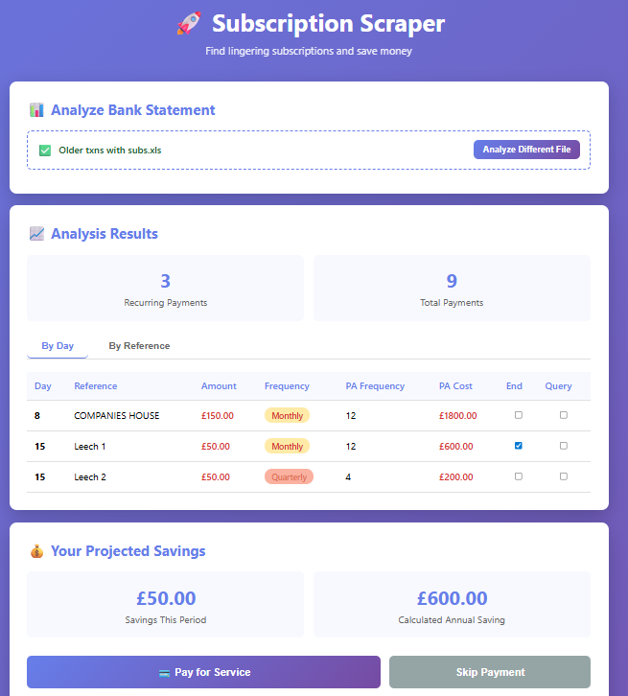

Closing Splash
In screen shot below, Customer has chosen not to pay. The only difference between this Closing splash – and the splash when a Customer has chosen to pay – is that the “Close and Pay” button will not be shown.
Note that this Splash is shown after the Customer has chosen whether to pay or not. We are working hard to avoid ‘take the money and run.’ We cannot force the Client to take value from our Services. But. Our ethos is that we want to drive value delivery. This is not instead of Profit. It is simply a higher priority than Profit.
Figure 2: Closing Splash, for Customers who have decided not to Pay
